ORM Normative Abstract Syntax and Semantics: non-normative glossary

ORM.net Proposed Recommendation

Version: Public BETA 3 - 12 January 2025
Editors: Enrico Franconi, Terry Halpin

Contributors to DRAFT 4: Clifford Heath, Peter Norman

Abstract

Object-Role Modeling (ORM) is a rigorous approach to modeling and querying at the conceptual level the information semantics of arbitrary domains. This glossary document lists key terms and symbols used in ORM, and briefly explains their meaning by means of examples. It shows examples of the main graphical conceptual model constructs - namely declarations, constraints, and derivation rules - together with their corresponding abstract syntactic expressions, and their semantics specified as closed first-order logic formulas. This non-normative document makes use of the definitions specified in the normative document defining the abstract syntax and formal semantics of ORM conceptual models. The semantics of an ORM conceptual model is defined by transforming the model to first-order logic axioms, whose finite models denote the legal abstract information structures of the conceptual specification.

Status of this Document

This section describes the status of this document at the time of its publication. Other documents may supersede this document. A list of the revisions of this technical report can be found in the ORM.net Technical Recommendations index at <https://gitlab.com/orm-syntax-and-semantics/orm-syntax-and-semantics-docs.git>.

This document is part of the ORM document suite. It summarizes the abstract syntax of the main graphical symbols used in ORM by means of examples. The companion document “ORM Abstract Syntax and Semantics: normative specifications” formally defines the core ORM concepts. Both documents of the ORM document suite can be found at
<https://gitlab.com/orm-syntax-and-semantics/orm-syntax-and-semantics-docs.git>.

This document is published on ORM.net as a Proposed Recommendation. If you wish to make comments regarding this document, please send them to <orm-semantics@googlegroups.com>, after having registered at <https://groups.google.com/group/orm-semantics>. All comments are welcome.

Once this document becomes an ORM.net Recommendation, it will be a stable document and may be used as reference material or cited from other documents. ORM.net's role in making the Recommendation is to draw attention to the specification and to promote its widespread deployment. This enhances the functionality and interoperability of data models based on ORM or other fact-based modeling approaches.

Change History

- Public BETA 3: fixed typos.
- Draft 4: Adopted concrete syntax, fixed errors and formatting, added ValueSyntax. See companion .xlsx file

Construct and Examples | Normative Abstract Syntax of Examples | Normative Semantics of Examples
Signature: Entity type name  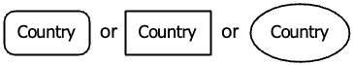 | Signature:  Entity Type name: Country
Signature: Value type name  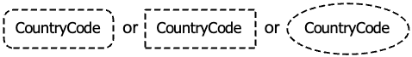 | Signature:  Value Type name: Country Code  (Case-sensitive. Spaces are allowed. Hyphenated words are allowed)
Signature: Value Syntax | Signature:  ValueSyntax(CountryCode /[A-Z][A-Z]/)  ValueSyntax(Population Natural)  (Instances of any Object type having a ValueSyntax may be identified by a value matching that syntax) | Values of this ObjectType must match the defined syntax.  Syntax is defined by matching a Regular Expression or the syntax of another ObjectType which has a (non-recursively defined) syntax.  Natural, Integer, Real, String, Date, Time and RegularExpression are predefined.
Signature: Predicate name  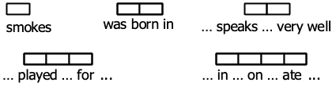  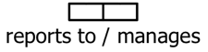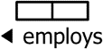 | Signature:  Unary predicate name: smokes, ? has cancer  Binary predicate names: was born in,  ? speaks ? very well  reports to, employs  Ternary predicate name: ? played ? for ?  Quaternary predicate name: ? in ? on ? ate ?  Hyphen-bound text: green- Frog has Pigment  Grenouille -verte à pigment  Alternate predicate name:  AlternatePredicate(reports to,  manages (reports to.2, reports to.1)) | has.greenFrog is the default role identifier.  àPigment.grenouilleVerte is the default role identifier.  Predicate names used in the normative semantics of these examples concatenate the words of the name in camelCase, without the question marks, whitespace or hyphen-bound text. If applied generally, this could cause distinct fact types to collide on the same predicate names. When this happens, a different approach to exemplifying predicate names is used, which includes the object type names in the formal predicate names, to make them distinct. ORM is a typed logic, and predicates are typed by the types of the role players.  Unary predicates may elide an initial ?, and binary predicates may elide implicit ? at both ends, where not ambiguous.  Words may be hyphenated, but hyphens between a word and a space or question mark signals hyphen-binding to a verbaliser.
Signature: Role name  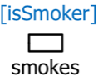  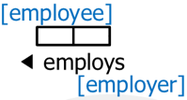 | Role names:  RoleNaming(smokes.1, isSmoker)  RoleNaming(employs.1, employer)  RoleNaming(employs.2, employee)  RoleNaming(drives.1, driver)  Signature:  Role identifier for the unary predicate smokes:  smokes.1  Role identifiers for the binary predicate employs:  employs.1, employs.employee | In the concrete syntax, default role names (where no explicit role name is provided) are derived from a unique domain object type name, potentially including hyphen-bound text.
Unary fact type  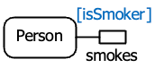 | FactType(smokes (Person))
Binary fact type  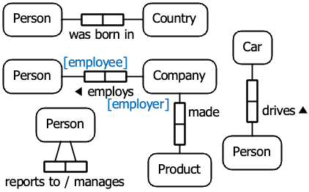 | FactType(was born in (Person, Country))  FactType(employs (Company, Person))  FactType(made (Company, Product))  FactType(? drives ? (Person, Car))  FactType(reportsTo (Person, Person))
Ternary fact type  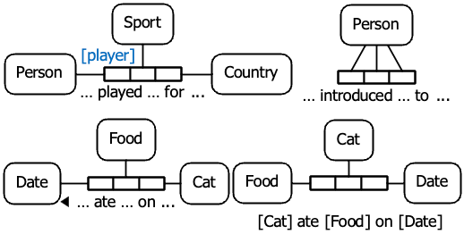 | FactType(?played?for?  (Person, Sport, Country))  FactType(? introduced ? to ?  (Person, Person, Person))  FactType(?ate?on? (Cat, Food, Date))
Quaternary fact type  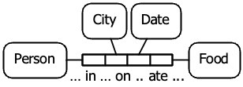 | FactType(?in?on?ate? (Person, City, Date, Food))
Objectification  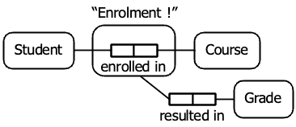 | FactType(enrolledIn (Student, Course))  Objectifies(Enrolment, enrolledIn)  FactType(resultedIn (Enrolment, Grade))
Uniqueness constraints on binary fact types  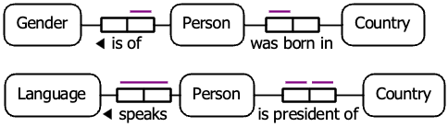 | Unique(isOf.1)  Unique(wasBornIn.1)  Unique(speaks.1, speaks.2)  Unique(isPresidentOf.1)  Unique(isPresidentOf.2)
Uniqueness constraints on ternaries  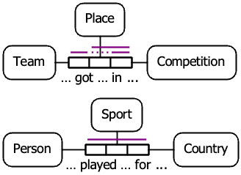 | Unique(?got?in?.1, ?got?in?.3)  RoleNaming(?got?in?.2, placing)  Unique(?got?in?.placing, ?got?in?.3)  Unique(?played?for?.1, ?played?for?.2,  ?played?for?.3)
Simple mandatory role constraint  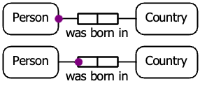 | Mandatory(Person, wasBornIn.1)
Inclusive-or constraint  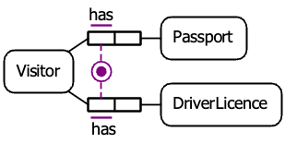 | Mandatory(Visitor,  hasPassport.1, hasDriverLicence.1)
Preferred internal uniqueness constraint  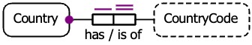 | Identification(Country, has.1 (has.2)) | well-founded(has)
External uniqueness constraint  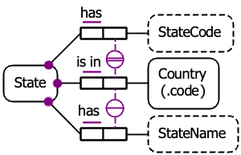 | ExternalIdentification(State  (hasStateCode.2, isIn.2))  ExternalUnique(hasStateName.2, isIn.2) | well-founded(hasStateCode ∪ isIn)
Object type value constraint  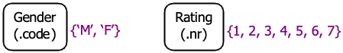  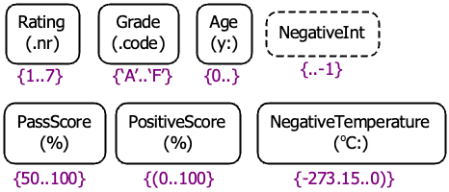  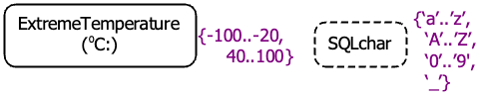 | ValuesOf(GenderCode (M F))
Role value constraint  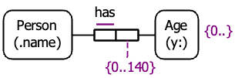 | ValuesOf(has.2 (0 … 140))
Subset constraint  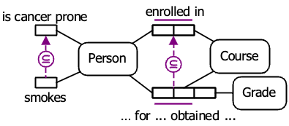 | Subset((smokes.1, isCancerProne.1))  Subset((?for?obtained?.1, enrolledIn.1)  (?for?obtained?.2, enrolledIn.2))
Join subset constraint  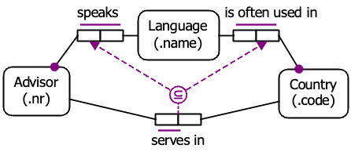 | JoinPath(P (speaks.1, speaks.2)  (isOftenUsedIn.1, isOftenUsedIn.2))  Subset((servesIn.1, P.1)(servesIn.2, P.2))
Exclusion constraint  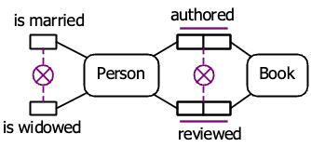 | Exclusive((isWidowed.1, isMarried.1))  Exclusive((reviewed.1, authored.1)  (reviewed.2, authored.2))
Equality constraint  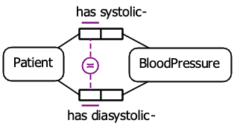 | Equal((has systolic-.1, has diasystolic-.1))
Subtyping  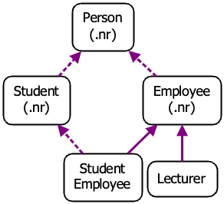 | Subtype(Lecturer, Employee)  Subtype(Employee, Person)  Subtype(Student, Person)  Subtype(StudentEmployee, Student)  Subtype(StudentEmployee, Employee)
Subtyping constraints  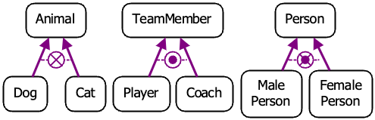 | ExclusiveSubtypes((Dog, Cat) Animal)  ExhaustiveSubtypes((Player, Coach) TeamMember)  ExclusiveSubtypes((MalePerson, FemalePerson)  Person)  ExhaustiveSubtypes((MalePerson, FemalePerson)  Person)
Internal frequency constraint  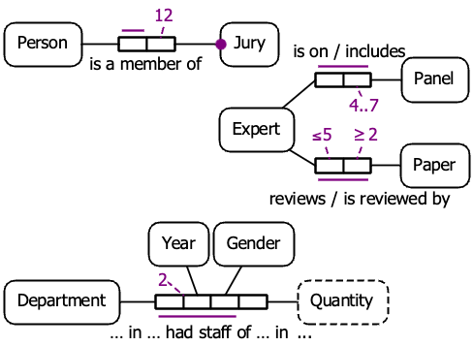 | Frequency(isAMemberOf.2 (12))  Frequency(isOn.2 (4, 7))  Frequency(reviews.1 (..5))  Frequency(reviews.2 (2..))  Frequency(?in?hadStaffOf?in?.1,  ?in?hadStaffOf?in?.2 (2))
External frequency constraint  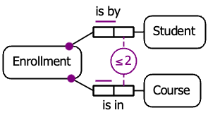 | ExternalFrequency(isBy.2, isIn.2 (..2))
Value-comparison constraint  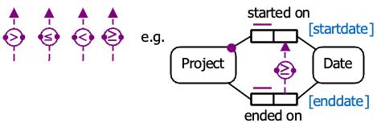 | ≥(endedOn.2, startedOn.2) | Or
Object cardinality constraint  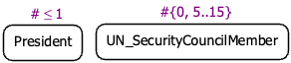 | TypeCardinality(President (0, 1))
Role cardinality constraint  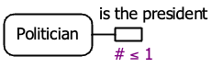 | RoleCardinality(isThePresidentOf (0, 1))
Ring constraints  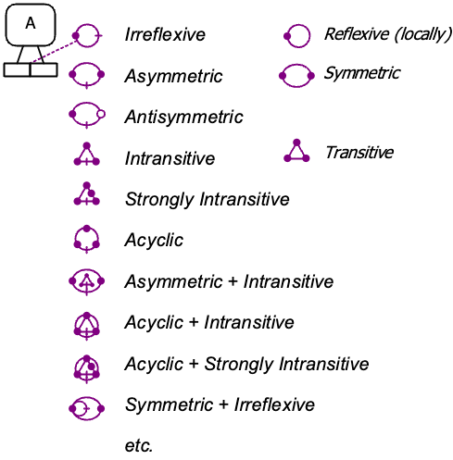 | LocallyReflexive(P.1, P.2)  etc. | etc.

Derivation Rules  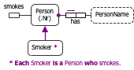 | SubTypeRule(Smoker, Person ∧ smokes)
[EXAMPLE DIAGRAM NEEDED HERE] | SubTypeSemiRule(Taxpayer, Person∧pays taxes)  SubTypeSemiRule(Taxpayer, Company∧pays taxes)  Note: semi-derivation uses directional implication which means there may exist Taxpayers who do not actually pay taxes.
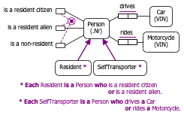 | SubTypeRule(Resident,  (Person ∧  (isAResidentCitizen ∨ isAResidentAlien))  SubTypeRule(SelfTransporter,  (Person ∧  ((drives.1 ➤ [drives.2 ⋈ Car]) ∨  (rides.1 ➤ [rides.2 ⋈ Motorcycle]))))  Note: SelfTransporter is typed as a Person, and the predicates drives and rides are both typed, so this example may be written more succinctly as merely:  SubTypeRule(SelfTransporter, drives.1 ∨ rides.1)  This principle applies throughout these examples.
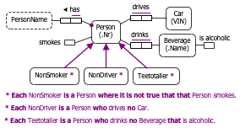 | SubTypeRule(NonSmoker, (Person ∖ smokes))  SubTypeRule(NonDriver,  (Person ∖ (drives.1 ➤ [drives.2 ⋈ Car]))  SubTypeRule(TeeTotaller,  (Person ∖  (drinks.1 ➤ [drinks.2 ⋈  (Beverage ∧ isAlcoholic)]))
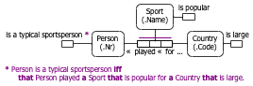 | FactTypeRule(isATypicalSportsPerson,  (Person ∧ ?played?for?.1 ➤  [?played?for?.2 ⋈ (Sport ∧ isPopular)]  [?played?for?.3 ⋈ (Country ∧ isLarge)]))
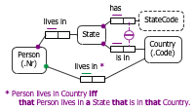 | FactTypeRule(livesInCountry,  (Person ∧ livesInState.1 ➤  [livesInState.2 ⋈ (State ∧ isIn.1 ➤  [isIn.2 ⋈ (Country ∧ ?x)])]),  (Country ∧ ?x))
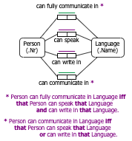 | FactTypeRule(canFullyCommunicateIn,  (Person  ∧ (canSpeak.1 ➤ [canSpeak.2 ⋈ (Language ∧ ?x)])  ∧ (canWrite.1 ➤ [canwrite.2 ⋈ (Language ∧ ?x)])  ),  (Language ∧ ?x)  )  FactTypeRule(canCommunicateIn,  (Person  ∧ ((canSpeak.1 ➤ [canSpeak.2 ⋈ (Language ∧ ?x)])  ∨ (canWrite.1 ➤ [canwrite.2 ⋈ (Language ∧ ?x)])  )  ),  (Language ∧ ?x)  )
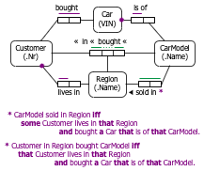 | FactTypeRule(soldIn,  (CarModel ∧ ?x),  (Region ∧  (livesIn.2 ➤ [livesIn.1 ⋈ Customer ∧  (bought.1 ➤ [bought.2 ⋈ Car ∧  (isOf.1 ➤ [isOf.2 ⋈ (CarModel ∧ ?x)])])])))  FactTypeRule(?in?bought?,  (Customer ∧  (livesIn.1 ➤ [livesIn.2 ⋈ (Region ∧ ?x)]) ∧  (bought.1 ➤ [bought.2 ⋈ (Car ∧  (isOf.1 ➤ [isOf.2 ⋈ CarModel ∧ ?y]))])),  (Region ∧ ?x),  (CarModel ∧ ?y))

